Mitchel Dauk

05/16/2024

CS-330-10863

Comp Graphic and Visualization

Southern New Hampshire University

Milestone One: Project Proposal

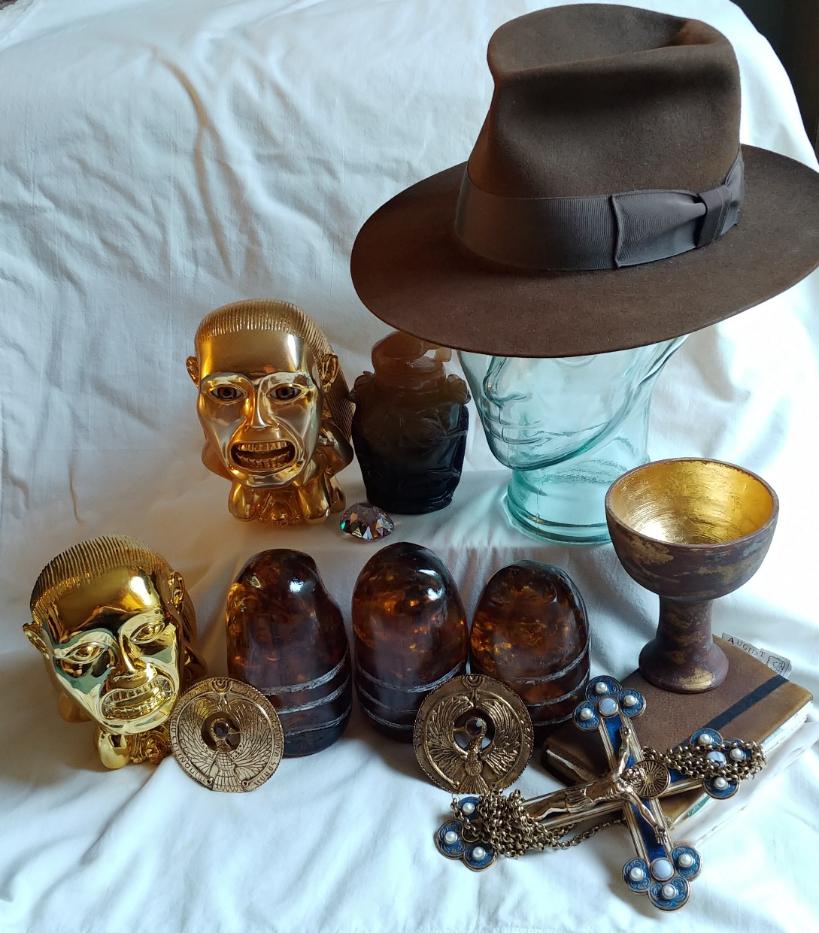

I am an avid fan of Indian Jones, so when I saw this opportunity, I thought that I should try it out. The objects I would like to replicate into 3D will be the cup, a single stone, the book, and the hat. These items are a good choice because while they are basic, they have significant meaning and can be replicated to 3D to make an iconic scene.

Cup – The cup will be made with a tapered cylinder, followed by a cylinder underneath. A short, tapered cylinder on the bottom will hold the cup in place. If possible, the worn effects and shine from the middle will illuminate the scene.

Stone – The stone will be a mixture of a sphere for the top and a cylinder for the base. Three, thin-like boxes or planes can match the lines on the stone. The color will be different than the cup, so they will clash on the table.

Book – The book will consist of a box. On the top and bottom of the box will be a thin box or plane to make it look like a book. The cup will not sit on top of the book. The box-type book will yield a different look from all the cylinders in the other objects.

Hat – The hat could be made with just a cylinder, but a slightly shifted tapered cylinder may be the best option. A torus on top will give the definition to the hat. Finally, a plane or thin curved box around the bottom will make the brim of the hat. The hat is meant to be larger and show a difference to the other items.

Plane – All of the items will sit on a table made of a plane. Hat on the left, stone in the middle, cup on the right, and book in front and in-between the stone and the cup. I believe the items I chose will be achievable, yet distinguishable to others who have a passion for the same movie props.

Resources

Ward, D. (2010, July 2). *Your Indiana Jones displays - lets see ’em*. RPF Costume and Prop Maker Community. https://www.therpf.com/forums/threads/your-indiana-jones-displays-lets-see-em.90148/page-43